**CUSTOMER INSIGHTS & LIFETIME VALUE ANALYSIS FOR DIGITAL WALLETS USERS**

**Introduction**

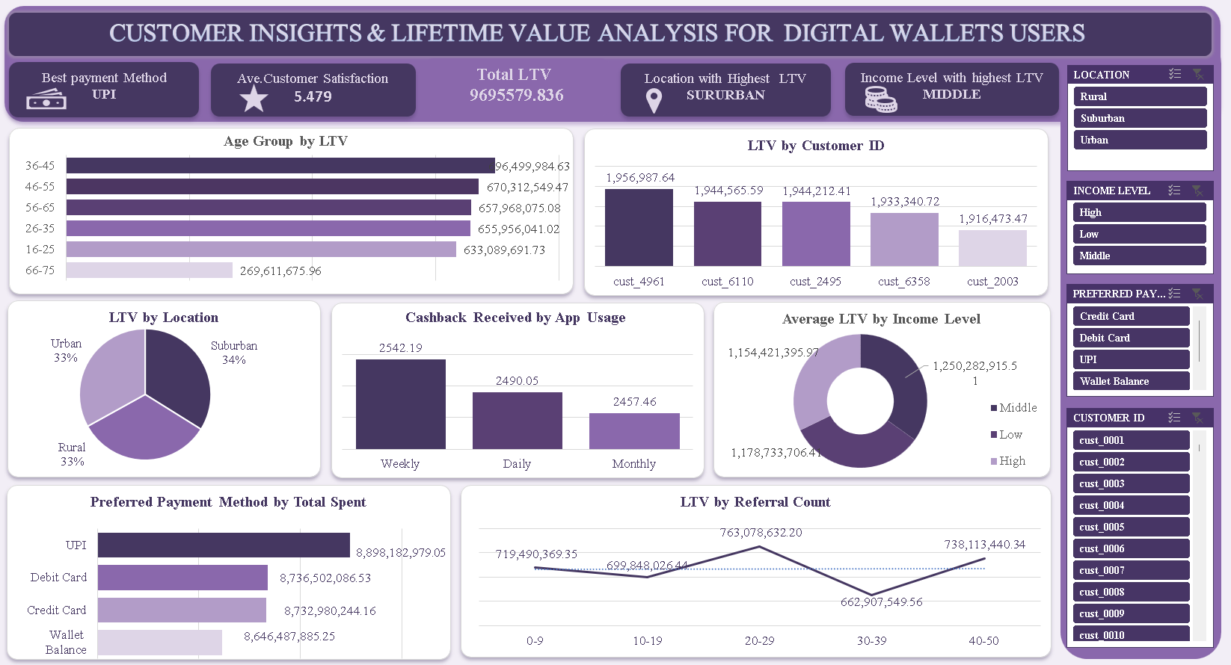

This report analyzes digital wallet user data from a financial technology platform. It focuses on identifying high-value customer segments, payment behavior trends, and key factors driving Lifetime Value (LTV) across different demographics and behavioral dimensions.

**Objective of the Project**

To uncover insights from customer LTV data that inform user engagement, product strategy, and revenue optimization in digital wallet applications.

**Problem Being Addressed**

FinTech platforms face challenges in customer retention and monetization. This analysis aims to pinpoint the most valuable customer segments and understand behavioral and demographic factors that influence LTV, helping decision-makers enhance user lifetime value and satisfaction.

**Key Datasets and Methodologies**

* **Datasets**: Digital wallet transaction logs, demographic attributes, usage patterns, and customer satisfaction data.
* **Methodologies**: Excel-based tools including Pivot Tables, bar/line/pie charts, conditional formatting, and SUMIFS calculations for aggregating and filtering customer data.

**Story of Data**

**Data Source**

Internal digital wallet application logs and customer support systems.

**Data Collection Process**

Automated collection via in-app tracking and customer relationship management (CRM) systems.

**Data Structure**

* **Rows**: Represent individual customers
* **Columns**: Include age, location, income level, payment method, transactions, cashback, support interactions, and LTV.

**Important Features and Their Significance**

* **LTV**: Central revenue metric; total projected value from each customer.
* **Age & Income**: Key segmentation attributes for targeted marketing.
* **Payment Method**: Indicates customer behavior and preference.
* **App Usage & Cashback**: Reflect engagement and retention incentives.
* **Support Tickets & Resolution Time**: Service quality indicators tied to satisfaction.

**Data Limitations or Biases**

* Lacks direct data on churn or inactive users.
* Potential underrepresentation of infrequent users or multi-device usage.
* Some behavioral attributes (e.g., sentiment or feedback) are qualitative and missing.

**Data Splitting and Preprocessing**

**Data Cleaning**

* Removed duplicate customers and standardized date/transaction formats.

**Handling Missing Values**

* Null values in categorical fields were excluded; numeric fields were imputed using means.

**Data Transformations**

* Aggregated LTV by age, income, payment method, and app usage.
* Converted categorical data into grouped formats for analysis (e.g., income levels, age bins).

**Data Splitting**

* **Dependent Variable**: Lifetime Value (LTV)
* **Independent Variables**: Age, Location, Income Level, Payment Method, Cashback, Transactions, App Usage, Referral Count

**Industry Context**

* **Sector**: Financial Technology (Digital Payments)
* **Stakeholders**: Product Managers, Data Analysts, Marketing Teams, UX Designers

**Value to the Industry**

* Identifies high-value customer groups.
* Optimizes customer engagement strategies.
* Informs product design and loyalty programs.

**Pre-Analysis**

**Key Trends**

* **Suburban customers** contribute the highest LTV (34% of total).
* **Middle-income users** show the highest average LTV (~$1.25B).
* **UPI** is the most lucrative payment method by total spend (~$8.89B).
* Highest LTV age group: **36–45**.

**Potential Correlations**

* Frequent app users (weekly) receive more cashback.
* High satisfaction correlates with low issue resolution time.
* Referral counts align with LTV but peak at 20–29 then decline.

**Initial Insights**

* LTV is driven more by behavior (usage, transactions) than age alone.
* Satisfaction scores are critical for long-term value retention.

**In-Analysis**

**Unconfirmed Insights**

* Does high loyalty point accumulation directly influence LTV?
* Are older users (66–75) low-value due to app design or adoption barriers?

**Recommendations**

* **Double-down on middle-income and suburban users** for upselling.
* **Enhance UPI experience** — the top payment channel.
* **Target 36–55 age range** — highest LTV group.
* **Offer cashback loyalty for weekly app users.**
* **Improve support ticket resolution times** to increase satisfaction and retention.

**Analysis Techniques Used in Excel**

* Pivot Tables to group LTV by customer attributes.
* Bar and Pie Charts for visual comparison.
* Line Graphs to track LTV by referral activity.
* Conditional formatting to identify high-LTV customers.

**Post-Analysis and Insights**

**Key Findings**

* **Best Payment Method**: UPI
* **Highest LTV Location**: Suburban
* **Top Income Level**: Middle
* **Top Age Group by LTV**: 36–45
* **Best App Usage Frequency**: Weekly
* **Customer Satisfaction Average**: 5.479
* **Total LTV**: $969,557,983.60+

**Comparison with Initial Findings**

* Initial trends were confirmed — middle-income, suburban, and UPI users offer the highest returns.
* Surprisingly, credit and wallet balances were not far behind UPI in total spend.

**Data Visualizations & Charts**

**Visuals Used**

* Bar Charts: Age Group vs LTV, Payment Method vs Total Spent
* Pie Charts: LTV by Location, Income Level
* Line Chart: LTV by Referral Count
* Cards: Key KPIs (Best Payment Method, Total LTV, Satisfaction Score)

**Explanation of Visualizations**

* Bar charts clearly depict top-performing age and payment groups.
* Pie charts show proportional LTV distribution across demographics.
* The referral line chart highlights where diminishing returns begin.

**Recommendations and Observations**

**Actionable Insights**

* **Focus on UPI** users — refine features and rewards.
* **Promote loyalty bonuses** for weekly active users.
* **Segment marketing toward 36–55-year-olds** in middle-income, suburban regions.
* **Monitor referral campaigns** to avoid saturation beyond 30 referrals.

**Optimizations or Business Decisions**

* Personalized rewards for mid-income users.
* Improve app UX for users aged 66+ to lift their LTV.
* Reduce support delays to boost satisfaction and loyalty.

**Unexpected Outcomes**

* Contrary to common assumptions, rural and urban areas contributed equally (33% each), suggesting untapped suburban dominance.

**Conclusion**

**Key Learnings**

* Behavioral metrics like app usage and referrals strongly affect LTV.
* Middle-income, suburban, UPI users between 36–55 form the most profitable demographic.
* Support speed and cashback drive engagement.

**Limitations**

* No data on churn or inactive user behavior.
* No longitudinal data to calculate full Customer Lifetime Value (only projection-based).

**Future Research**

* Add churn modeling to refine true LTV.
* Include cross-device usage and transaction timing patterns.
* Run sentiment analysis on customer support interactions.

**References & Appendices**

**References**

* FinTech Internal Transaction Logs
* Excel Pivot Table Documentation
* LTV Modeling Best Practices

**Appendices**

* Dashboard Snapshot (Refer to attached image)
* Detailed LTV Tables by Segment
* Support Interaction Stats